Published 29th. January 2021 by Jørn Watvedt for UpWork project.

Phase 2 Rev 0 issued 4th May 2021 by Jørn: Changes to Phase 2 paragraph only

Joystick piloting for outboard motorboats was a popular topic 10 – 15 years ago, when the major manufacturers started developing and offering these systems. However, the excitement has much died off because of complexity, limited user benefit, high price, and the inherent limitations of big money big industry proprietary systems.

However, since then, there has been a revolution in vehicle piloting driven mostly by open-source contributions to the RC and especially RC / autopiloted drones. Now time is right for revisiting boat joystick piloting and all the current smart navigation opportunities that has become available thru ArduPilot and the associated hardware. Not only that, but quality, reliability and safety of these current technologies are certainly competitive, compared to current industrial solutions (which are 10 years old …..)

Outboard motorboats with 2 motors that are controlled independently in respect to throttle, shift, steering, and trim have vast opportunities for total boat control. Much like that recent controllers with gyro/compass/GPS/PID instrumentation made drone piloting possible, these same technologies are now ready to unleash similar transformation for outboard motorboats with 2 (or more) engines.

Now time is right to start, and start small, with a common RC boat, equipped with 2 outboard motors with independent controllers. Make it work with regular dual joystick RC controller, one joystick for each motor and a sea-trial will be convincing; Perform a sideways walk by vectoring the engines such that the resultant vector pushes the boat directly sideways. And so on!

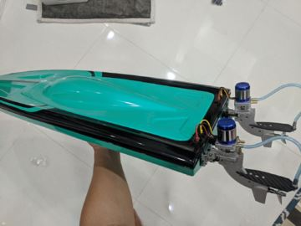

The objective of this project is to start small, start simple with current RC boat equipment and iterate and iterate and iterate. Maybe one day we feel confident to move the controller onto a full-size boat.

**Phase 1 conclusions**

**Diagram conclusion:**

Replace “servo motor for reverse bucket” with “servo motor for steering +/- 45 dgr.”

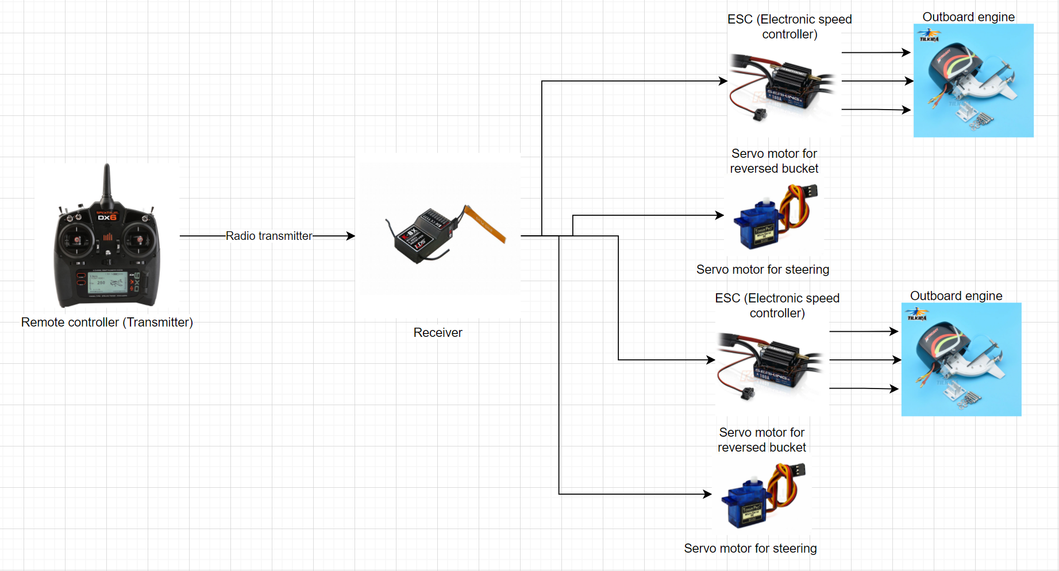

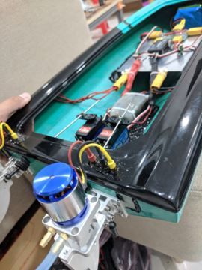**Finalized boat**

Our plan is to replace the original The KV3000 motors with motor with KV1100.

Reason is that the KV3000 motor is not possible to control precisely at low RPM = when starting.

No other changes are expected at this point.

The most difficult is attaching motors to the back and choosing transom position.

For future works, the experiences are:

. A “profile” of back side must be extract to the paper by redrawing. Put the motor to this paper for redraw the motor’s holder profile. After that, paste this paper back to the boat and start drilling holes.

. Drilling needs from to be done in from smallest drill bit to largest one (Do not use the largest at the first time)

. Water proof is the needed

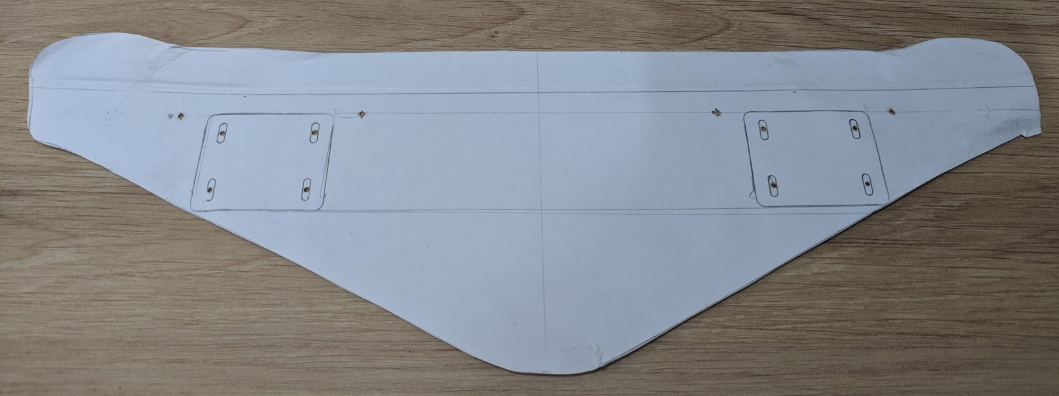

Example of boat’s backside profile

**BOM Bill of Materials updated to As Built**

|  |  | Quantity | Estimated Cost | Total | Remarks |
| --- | --- | --- | --- | --- | --- |
| **Engine** |  |  |  |  |  |
|  | Outboard | 2 | $100 | $200 | <https://vi.aliexpress.com/item/32878931653.html> |
| **New motor** | SUNNYSKY X2216 1100KV Outrunner brushless motor for multereo quadcopter | 2 | USD 20 | USD 40 |  |
| **Chassis** |  |  |  |  |  |
|  | Single hull | 1 | $40 | $40 | Vietnamese local store |
| **Controller** | Transmitter FRSky QX7 | 1 | $130 | $130 |  |
| **Receiver** | Receiver X8R | 1 | $34 | $34 | Kết quả hình ảnh cho recevier x8r  1Km range in airbone, expected 700m in water  It has SBUS channel which is compatable to Ardupilot in the future |
| **ESC** | Reversible ESC | 2 | $41 | $82 | <https://vi.aliexpress.com/item/4000379124148.html?spm=a2g0o.productlist.0.0.5e185b14G3B6kG&algo_pvid=4be96b4c-7aed-435c-9d64-196452ffc3b9&algo_expid=4be96b4c-7aed-435c-9d64-196452ffc3b9-33&btsid=0bb0623c16195695143053870ef003&ws_ab_test=searchweb0_0,searchweb201602_,searchweb201603_> |
| **Servo** |  |  |  |  |  |
|  | JX DC5821LV 20 Kg | 4  2 | $21 | $84  $42 | <https://www.ebay.com/itm/JX-Waterproof-Metal-Gear-JX-DC5821LV-20KG-Large-Torque-Digital-Coreless-Servo-/174125079363>  Image 1 - JX-Waterproof-Metal-Gear-JX-DC5821LV-20KG-Large-Torque-Digital-Coreless-Servo  Water proof |
| **Batteries** |  | 2 | $50 | $100 |  |
| **Accessories** | Glue, water cooling pipe, water pipe separator, servo link, screw… | 1 | $50 | $50 |  |

Estimated cost is $650,- + new motors 80 = 720 + work

**Process timeline Phase 1**

Parts arrived at end of March

( Due to Covid 19 parts availability and delivery has been very difficult)

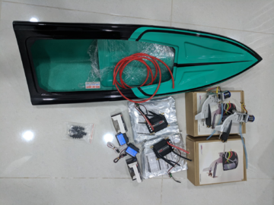

Boat was ready for sea-trial 15th. April



Phase 1 is being completed, including updating of documentation, by the end of April.

Effectively, the Phase 1 was completed during the month of April 2021.

**Work hours:**

Work budget for Phase 1 as per Vu estimate: $7.29 for construction, setting up and testing

About the budget hours, I will spend 20 hours per week, so we have 3 weeks, it would be 60 hours in total.

**Phase 1: RC boat with 2 outboard engines controlled by individual joysticks.**

IMPORTANT: Scope of Phase 1 also includes BOM and budget material and work for Phase 2.

Before the sea-trails:

. Make sure motors and servos work properly

. Batteries, power distribution, receivers and other non-water resists must be placed as high as possible (the should be light because tall COG of the the boat is not good)

. Water proof the motor connectors (with hot glue)

. Enough battery

. Do not forget the controllers (this happens to everyone sometimes!!!)

During the sea-trail

. Do not close the boat with the cap so we can observe serious water leak at very first water surface contact

. Slowly put the boat into water surface, slowly let it go and make sure it not to flip of sink

. Observe the water leak if it happens

. If the leakage is serious, find the source by slowly dip the boat into water and observe.

. Water level should be low enough with respect to the edge:

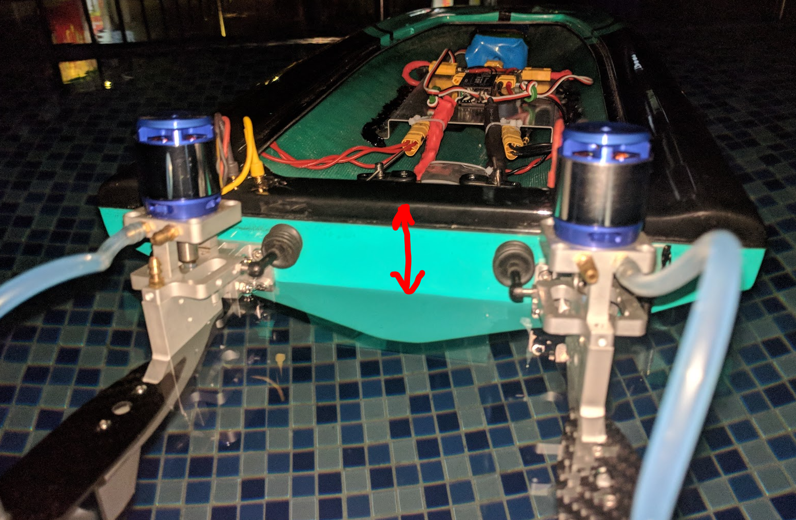

. Close the hull with its cap by non-sicky tape

. Input low sticks forward and observe any odds (if there is), increase the stick until full speed, lower down the stick (do not release quickly). Repeat the same for reward direction

. Confidently steer the boat with servos and try 2 methods of steering: differentialy and skid

**Phase 2: Add simple controller for software vectoring of motors.**

Objective of Phase 2:

*“Joystick operation of a vehicle, require that the joystick position be continuously converted into a drive signal in such a way that the joystick operation feels natural and intuitive to the operator. This is surprisingly complicated, especially in the transition into lower and zero signal from one axis while another axis still is active. Consequently, the objective of Phase 2 is to focus on joystick-to-drive conversion and exploiting multiple strategies such that we can compare and finalize a strategy, which most likely is going to be a combination of algorithms and mapping.”*

Just to be clear on scope of Phase 2, here is a list of what is **NOT** included:

* Boat external forces, like wind, waves and water current
* Linear or angular inertia of boat, or forces by inertia
* GPS, gyro or compass
* PID controller

Algorithms:

As a baseline, we shall fully develop and test 3 different strategies: Skid steering, differential steering and vectored steering.

To this Project, these strategies are defined as:

|  |  |  |
| --- | --- | --- |
| Skid steering: | Differential steering: | Vectored steering: |
|  |  |  |

Skid steering and differential steering definition is based on this video: <https://www.youtube.com/watch?v=F3G0sUz3_Jw>

Each strategy is further described in these documents:

* Skid Steering 1 Kendra Joystick to drive formula.docx
* Differential Steering 1 Impulsadventure code sample.docx
* Vectored Steering 1 Joystick to Drive lookup table.docx

In addition to these 3 strategies, we also need plain manual operation:

* Dual joystick = Forward/backward and steering individually for the motors. Purpose is to always be able to go back and test specific maneuvers manually.
* Maybe need ?? (Single right joystick = Strict synchronized operation of motors in tandem. Purpose is to experience this typical ( low cost) RC boat control.)

IMPORTANT NOTE: AFTER that these strategies have been tested, other strategies may be tested as well, if we come up with good ideas.

Axis definition, in marine lingo:

X-axis = The longitudinal, or roll axis, is an imaginary line running horizontally through the length of the ship, through its center of mass, and parallel to the waterline. A roll motion is a motion around this axis.

Y-axsis = The transverse, lateral axis, is an imaginary line running horizontally across the ship and through the centre of mass. A pitch motion is an up-or-down movement of the bow and stern of the ship.

Z-axis = The vertical, or yaw axis, is an imaginary line running vertically through the ship and through its centre of mass . A yaw motion is a side-to side movement of the bow and stern of the ship.

This creates a conflict with conventional joystick definition of X and Y axis, so we must refer to joystick axis as “joystick horizontal”, “joystick vertical” and “joystick z-axis”

User interface

RC transmitter Taranis Q X7 16 axis with open source screen programming

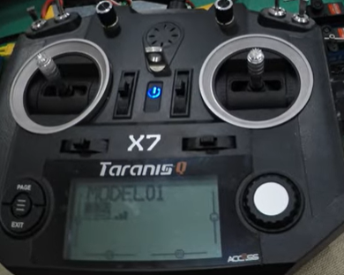

X and Y axis: Right hand joystick

Z axis: Left side joystick moving horizontally

Switching between programs

Timestamp feedback on screen

Instead of programing for this controller (LUA script), the log of sticks will be capture in Teensy for saving time

Hardware list

Must be completed by Vu, here is what I expect:

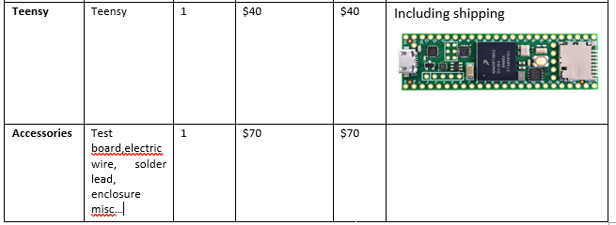

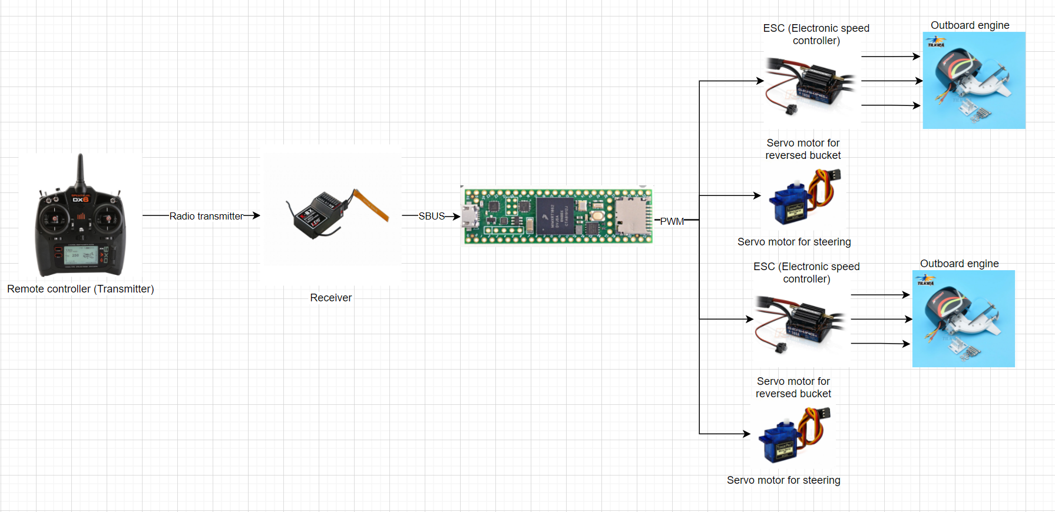

Hardwares connection: Teensy as middle control for implementing 3 types of steering

One more thing:

Counter rotating propellers may be required to achieve symmetrical control.

[http://www.offshoreelectrics.com/pro...prod=oct-x442r](http://www.offshoreelectrics.com/proddetail.php?prod=oct-x442r)  
  
[http://www.offshoreelectrics.com/pro...?prod=oct-x442](http://www.offshoreelectrics.com/proddetail.php?prod=oct-x442)

Phase 2 milestones:

Phase 2a: Complete hardware upgrade.

Installation of Teensy, etc.

MAYBE also add a fallback switch that allow strict manual control as in Phase 1, in case there is controller or software problems.

Phase 2b: Retain current manual operation thru the Teensy controller:

* Dual joystick = Forward/backward and steering individually for the motors. Purpose is to always be able to go back and test specific maneuvers manually. – yes, a backup line will be implemented in the code for rolling back to the phase 1 control
* Maybe need ?? (Single right joystick = Strict synchronized operation of motors in tandem. Purpose is to experience this typical ( low cost) RC boat control.) – maybe we do not neet this one

**10 hours** for phase 2a and 2b: hardware upgrading

Phase 2c: Skid steering

Estimation **10 hours** for coding and testing

Phase 2d: Differential steering

Estimation **10 hours** for coding and testing

Phase 2e: Vectored steering

Including measurements of the pull forces that is required to calibrate the lookup tables.

Estimation **30 hours** for coding and testing, most of the time is for recalibrating the table

For measuring the speed, we can use the stop watch

For measuting the force, we can try the hook scale:

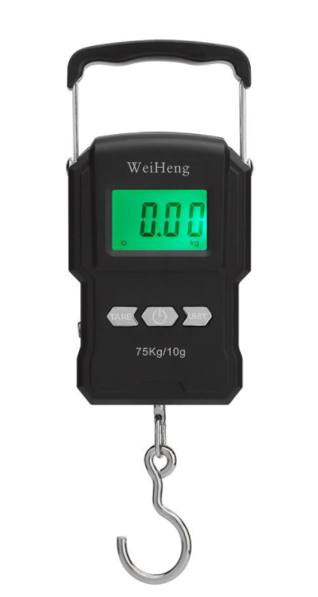

Phase 2f: Sea – trial with Lunar Loop Test.

Run a (subjective) test with each for the controller options, and make a short note about each one.

Estimation **5 hours** for coding and testing

Phase 2g: Summary

Need a short report with status and comments about development.

Final hardware configuration.

Test result

Estimation **2 hours** for coding and testing

NO CHANGES MADE BEYOND PHASE 2.

**Phase 3: Define system hardware and software.**

Now we are ready to define with ArduPilot and what hardware to use for compass, gyro and GPS.

Issues: Cost, availability, competence required, and so on.

Ardupilot has several steering options:

<https://ardupilot.org/rover/docs/rover-motor-and-servo-connections.html>

Also different versions of vectored thrust:

<https://ardupilot.org/rover/docs/rover-vectored-thrust.html#rover-vectored-thrust>

Joystick piloting allow straight sideways movement of boat, as an illustration of what is possible, by vectoring.

Sketch explaining motor vectoring for sideways movement: Motor A and Motor B have angular direction and force, which is revectored into Ax/Ay and Bx/By respectively.

The resultant force R = Ax+Bx is pushing the boat sideways IF resultant moment from all forces around “COJ” ( Center of Joystickoperation = think of CoG Center of Gravity but for water friction forces) = 0 zero. Controller must be able to run this calculations.

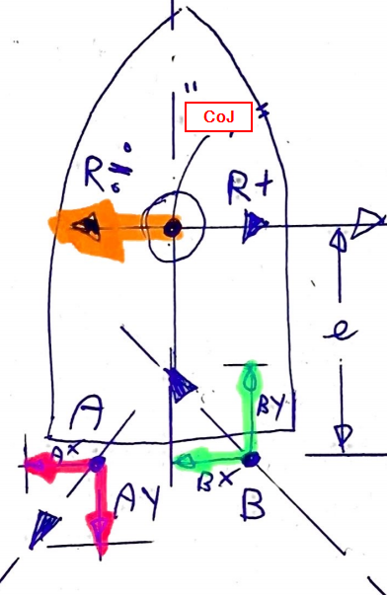

Ardupilot has several steering options:

<https://ardupilot.org/rover/docs/rover-motor-and-servo-connections.html>

Also different versions of vectored thrust:

<https://ardupilot.org/rover/docs/rover-vectored-thrust.html#rover-vectored-thrust>

**Phase 4:**

Update Boaty McBoatSurFace with new System for sea trials.

Identify issues and strategies to solve these issues.

**Phase 5:**

First full RC system

**Phase 6:**

RC System Ver 1.0

**Phase 7:**

Define Real Boat System

Real Boats us NMEA 2000 for data transfer, and there is an Open Source solution for communication:

<http://signalk.org/>

We are going to use Raspberry PI:

<https://seabits.com/nmea-2000-powered-raspberry-pi/>

**Phase 8:** Build hardware for Real Boat System.

**Phase 9:**

Develop and install software on the Real Boat System. Sea Trials

**Phase10:**

Real Boat System Ver 1.0